**Title**

**Example of the design of the report abstract**

**(**Times New Roman, 14 pt, Sentence case**)**

*Akhmetov А.А.,а Sokolov S.S.,b Makarov М.М.а*

(Times New Roman, 14 pt, Italic, the speaker emphasized)

аal-Farabi Kazakh National University, 050040, Almaty, Kazakhstan,  
bInstitute of Geology and Mineralogy, 630090, Novosibirsk, Russia

Akhmetov А.А., Bachelor's degree 4th year

(Times New Roman, 14 pt, speaker status)

e-mail: akhmetov@live.kaznu.kz

Text text text text text text text text text text text text text text text text text text text text text text text text text text text text text text text text text text text text text text text text text text text [1].

Text text text text text text text text text text text text text text text text text text text text text text text text text text text text text text text text text text text text text text text text text text text [2].

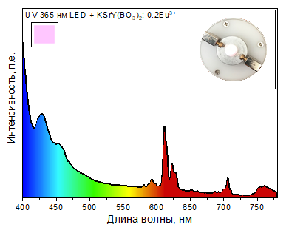

Figure 1. Figure title **(**Times New Roman, 14 pt, Sentence case**)**

**Bibliography**

1. Ахметов А.А., Петров П.П. Название книги, 2006, **42**, 774.

2. Petrov P.P., Sidorov S.S. V-th International Congress on Chemistry, 2010, London, **2**, 545.

3. Ахметов А.А., Петров П.П., Макаров М.М. Патент 3333333 РК, 2024.

4. Соколов С.С. Название книги. – М.: Химия, 1966. – 768с.

The work was carried out with the financial support of the Ministry of Education and Science of the Republic of Kazakhstan, project AP00000000.